PRESS RELEASE – SEPTEMBER 20TH 2013

REVELATION AND THE CSEM – A TIMELY BOOST FROM THE SWISS GOVERNMENT
THE ADVENTURE CONTINUES FOR THE MAGICAL WATCH DIAL®

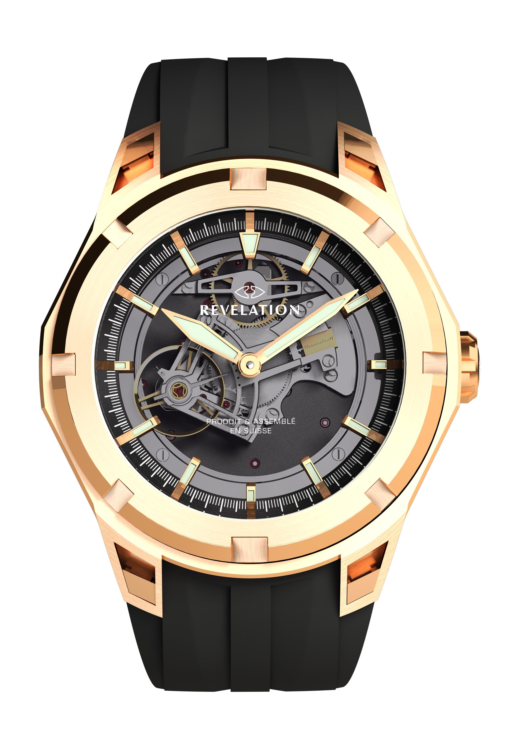

Two watches in one thanks to the MAGICAL WATCH DIAL® patent

The Haute Horlogerie brand REVELATION, backed by the CSEM, has just received a significant and tangible token of support from the Swiss Confederation in the form of funding provided through the CTI (Commission for Technology and Innovation). This grant is intended to further the development of the unique concept devised by the young Vaud-based company, that can thus now establish itself as the undisputed leader in this innovative technology.

In 2007, REVELATION filed a patent for an ingenious optical system making it possible to wear two watches in one. After five years of development, the watch brand was ready to present the public at large with the MAGICAL WATCH DIAL® fitted inside its first collections. This magical dial turns from black to translucent, thus revealing the openworked ‘skeleton’ movement of the watch – either a tourbillon or a chronograph, depending on the model chosen.

As is often the case for a number of SMEs, the youthful brand lacked the necessary resources when it came to capitalising on this original idea and extending this new technical territory previously uncharted by the watch industry – especially with all available energy focused on setting up an international distribution network. The CSEM therefore suggested that REVELATION founders Anouk Danthe and Olivier Leu submit a funding request to a specialised body: the CTI (Commission for Technology and Innovation). This request has now been accepted by the experts of the Swiss Confederation who have just agreed to allocate a grant for this ambitious project.

Anouk Danthe expressed her gratitude in enthusiastic terms: “We as Swiss entrepreneurs are very lucky that our country does its utmost to encourage innovation. It is amazingly fortunate that the State has not only understood the fact that the economy is effectively driven by SMEs, but is also prepared to provide concrete means to achieve such goals such as the CTI!”

The two entities will thus be able to reinforce their fruitful cooperation in order to develop new astonishing optical effects destined to equip new twin-faced watch models. Ladies will indeed soon be able to share in the pleasure experienced by the first lucky owners of a REVELATION… However, the need to preserve manufacturing secrecy means no more can be revealed at this point!

About CSEM

CSEM – an innovation centre

CSEM SA is a private applied research and development institute specialising in micro- and nanotechnology, microelectronics, system engineering, as well as IT and communications technologies. Dozens of products used in everyday life stem from CSEM developments in fields such as automation, watchmaking, medical technologies, pharmaceuticals, cleantech, security and transport, and have been transferred to industry. The CSEM has around 400 highly qualified employees in the fields of science and technology, spread across the CSEM sites in Neuchâtel, Zurich, Muttenz, Alpnach and Landquart. To learn more, consult the www.csem.ch website.

About REVELATION

REVELATION- Exceptional horological creations

The REVELATION watch brand is distinguished by its unique patented MAGICAL WATCH DIAL® concept. The company, founded in 2007 by Anouk Danthe and Olivier, designers who are united both in private life and professionally, is located in the delightful vineyard setting of Lully-sur-Morges.
The two founders decided to create their own brand to develop two of their own unique creations: an in-house “Manufacture” movement, the TOURBILLON MANEGE®; and an innovative optical mechanism, the MAGICAL WATCH DIAL®.
These innovations led to the historic launch of the R01 DOUBLE COMPLICATION, a 15-piece limited series that was soon followed by equally prestigious new collections.

Photo© PR R04 MAGICAL WATCH DIAL® + 2 soldats R04 ouvert R04 fermé/Photo© laser salle blanche au CSEM – Muttenz/Photo© nanostructures CSEM ci-dessous en basse définition.

